Google Play store insights

The data related to google play store apps has been analysed and the insights are included in this report. The insights could be useful to an entrepreneur or an internet company to understand in which area is there a need for quality apps. The insights will also be useful, if company is planning to launch new app. They can estimate the profits that they can generate.

The trend are as below:

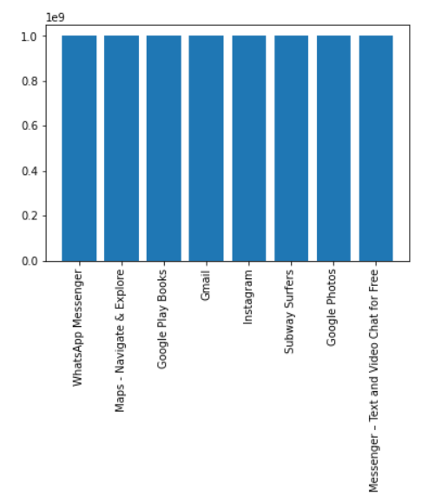

**Trend #1:** The most downloaded apps have downloads of around a billion. Thus, there are roughly billion android users.

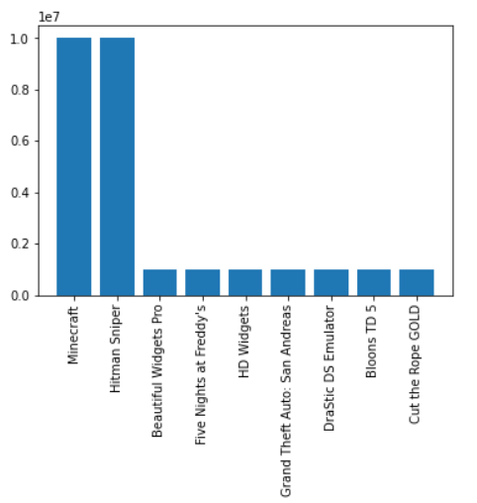

**Trend #2:** paid apps have considerably less users than the free apps and paid apps are mostly games unlike free apps where the apps are some sort of productivity tools to make our lives better.

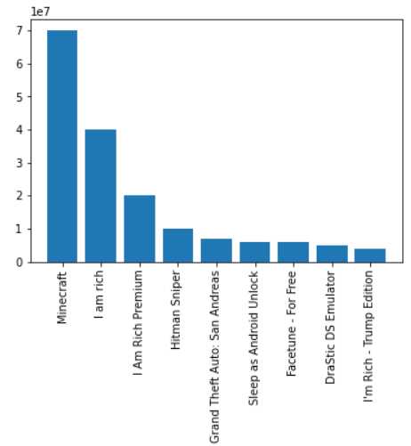

**Trend#3:** Assuming that all the downloads represent paying customers . The most revenue from downloads is around 10 million.

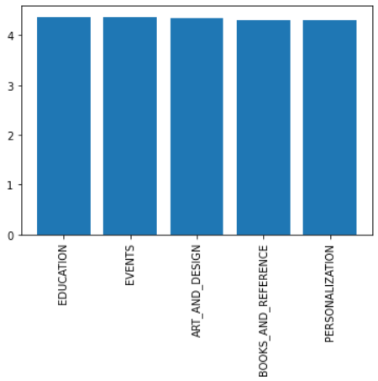

**Trend#4:** The categories with highest rating imply that category has matured and a newcomer might have to face tough competition.

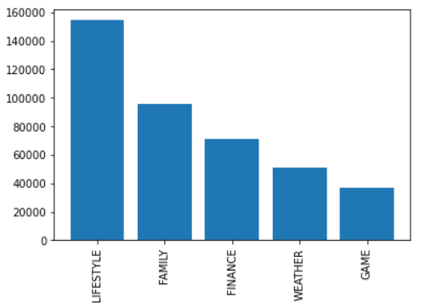

**Trend#5:** The categories with highest revenue lifestyle ,family, finance etc. Top 10 in lifestyle are as below:

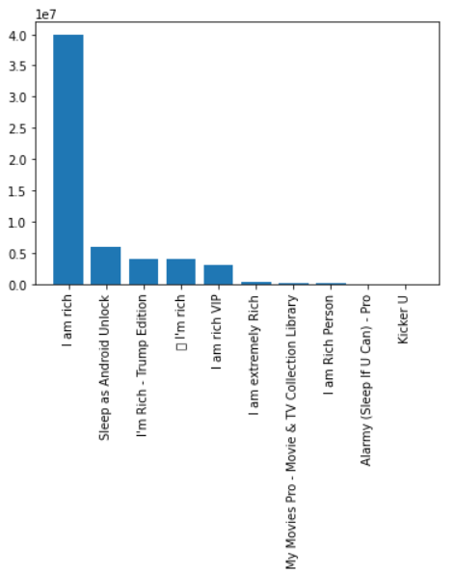

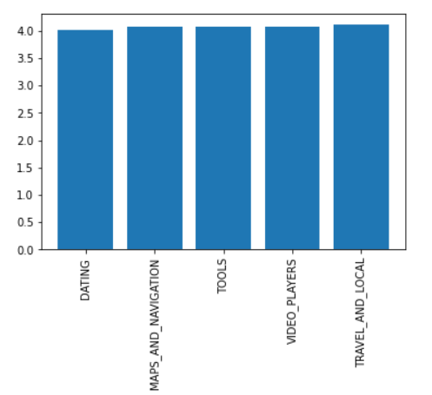

**Trend#6:** Dating category has scope. For maps , google maps generally suffices. Video players also one person might not need multiple apps. Travel related there could be multiple apps.

Insight: There is weak positive correlation between revenue and rating of the app. There is slight negative correlation between the size and rating. Thus, developer should focus on optimizing for the size of the app.

**Key takeaways:**

* **One can expect on average to earn 0.5 million from downloads**
* **Dating category has poorest rated apps. Thus, good opportunity for an entrepreneur.**
* **Rating is positively correlated with revenue.**
* **Lifestyle apps show most revenue from downloads like motivation or sleep related.**